HPC and Big Data – Information Visualization Assignment

Once I unzipped the file, I checked the size, which is corresponding to the one indicated in the assignment
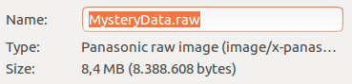

If the dimensions of a single image are 256x256, there are 128 images (8,388,608/(256x256)); otherwise, if they are 512x512, the number of images is 32 – since each dimension is doubled, the number is divided by 4.

I selected “unsigned char” as Data Scalar Type because each pixel is represented using 1 byte.

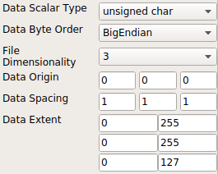
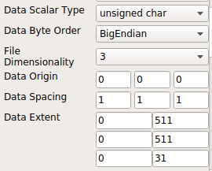

Using the Histogram filter, we find two spikes in the distribution: one is place in the interval [0, 25] and the second one in the interval [50, 75].

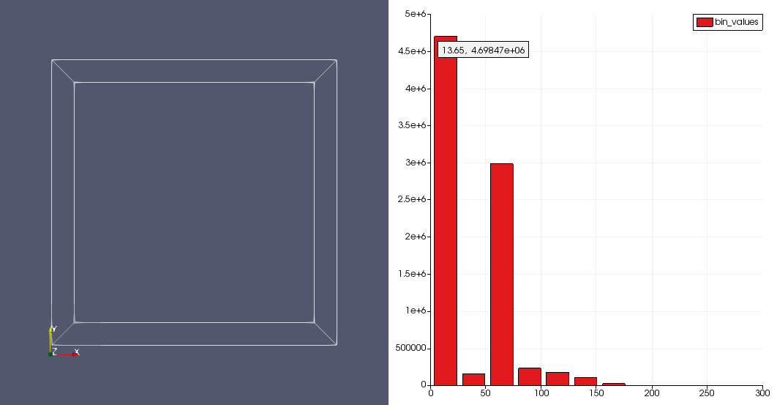

I added a Contour filter in order to visualize the Surface of the object (Isosurface value 25), but instead of a single one I obtained two object, so I changed the Data Extent matrix

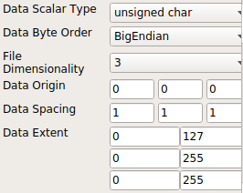

The result is a face of a person which is presumably covered in blood.

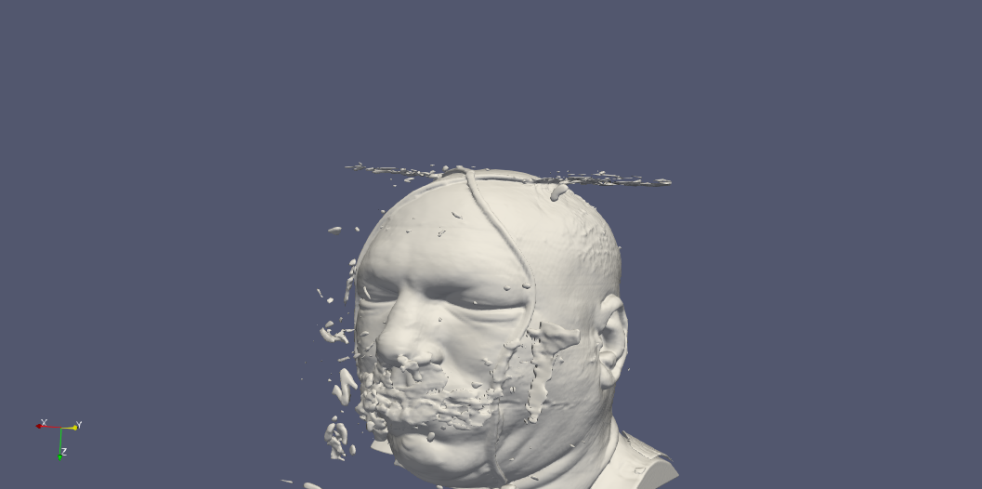

I added the remaining interval (i.e., [50, 75]) found thanks to the histogram and set opacity to 0.3. We can see that there are some strange stains between the skull and the skin, which could mean an intracranical effusion.

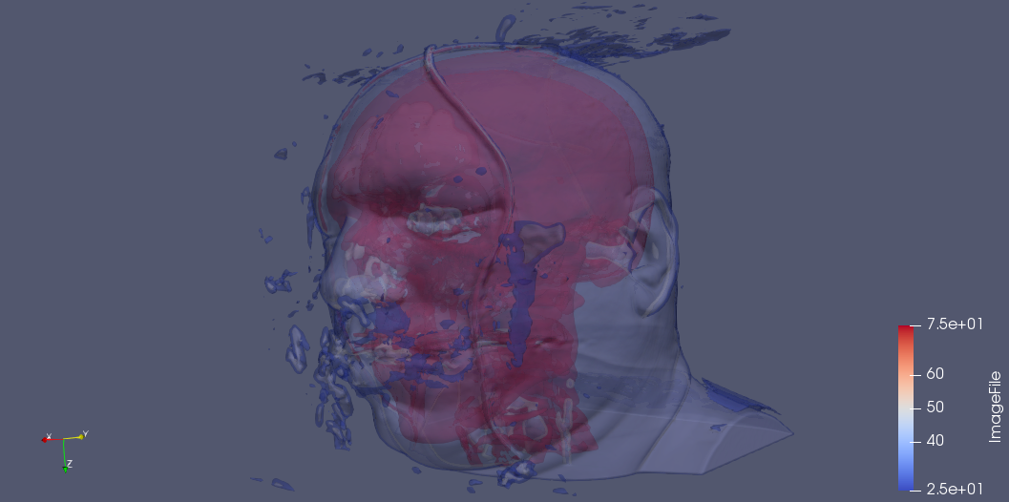
In order to understand better what happened, I removed the previous values for the Isosurface, keeping only 75 as value.

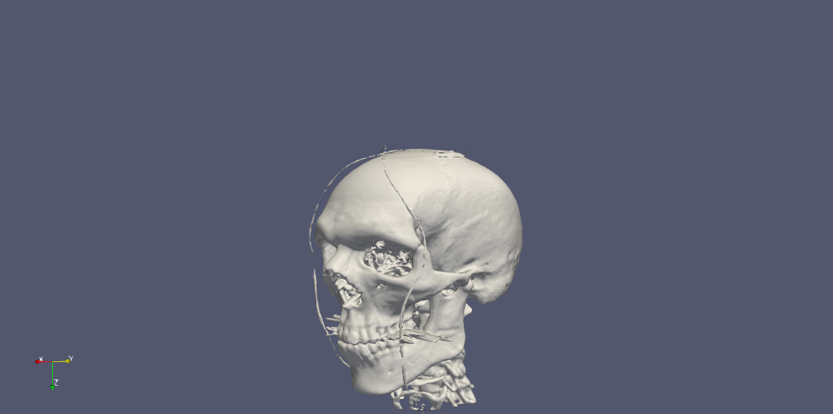

We can see that there is something like needles in the mouth of this person. If we rotate the image, we can also see that his jaw is broken

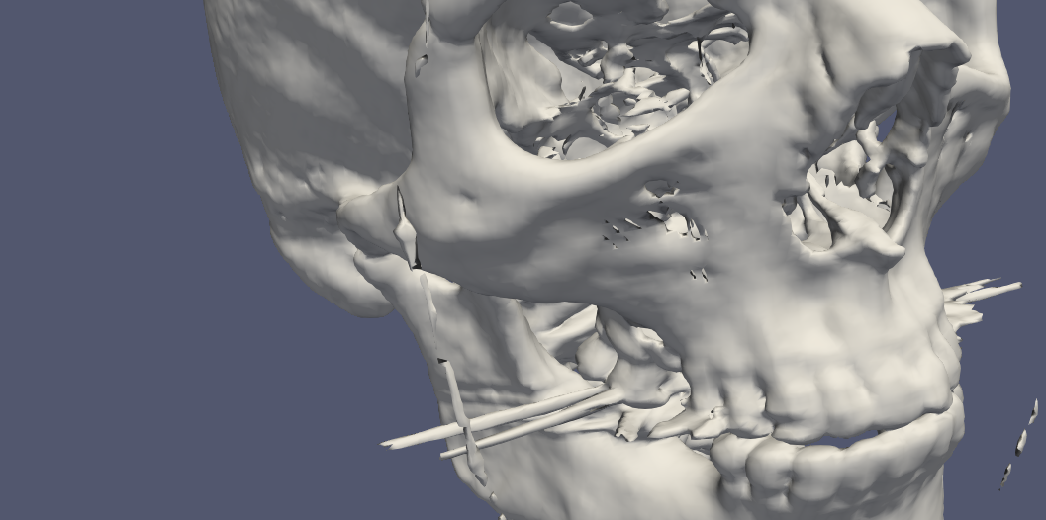

In fact, if we check better the initial image we can see that the tips of the needles and also a lot of blood coming out from his mouth.

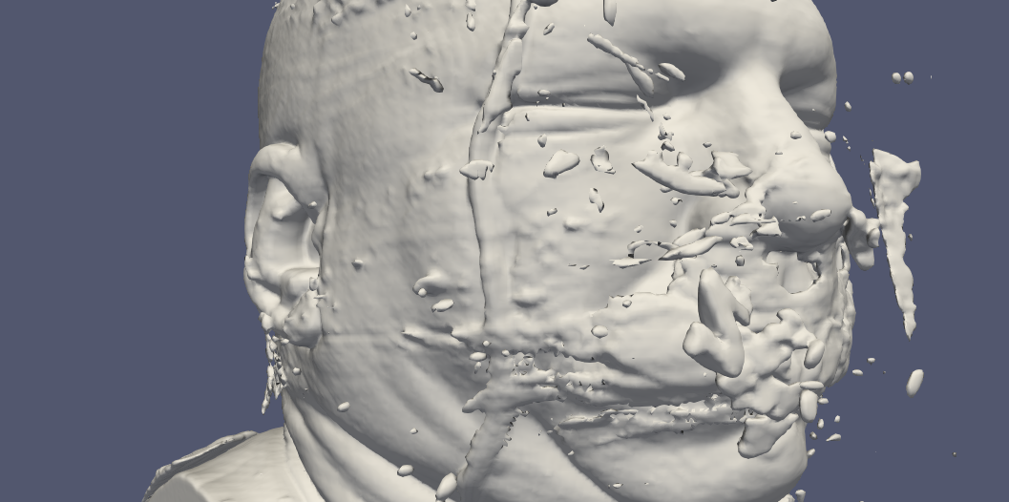

The most likely hypothesis is that this person has been assassinated using those needles, thus loosing a lot of blood from his mouth. However, it is not clear where the two blood streams on his head are coming from, since I did not found any other abnormality.

